**NAAN MUDALVAN ASSIGNMENT**

**NAME:** HARIKRISHNASINGH R

**DEPARTMENT**: BE ELECTRICAL AND ELECTRONICS ENGINEERING

**COLLEGE**: 8110 IMAYAM COLLEGE OF ENGINEERING

**NAANMUDHALVAN COURSE**: DIGITAL MARKETING

**NM ID**: 60B35D7438C16E1A1C84A33A6C8A52EB

ASSIGNMENT 1:

Create a blog or website using Blogspot and word press. Customize the theme design and post new article with 500 words.

URL: <https://haritransport10.blogspot.com/2023/10/hari-transport.html>

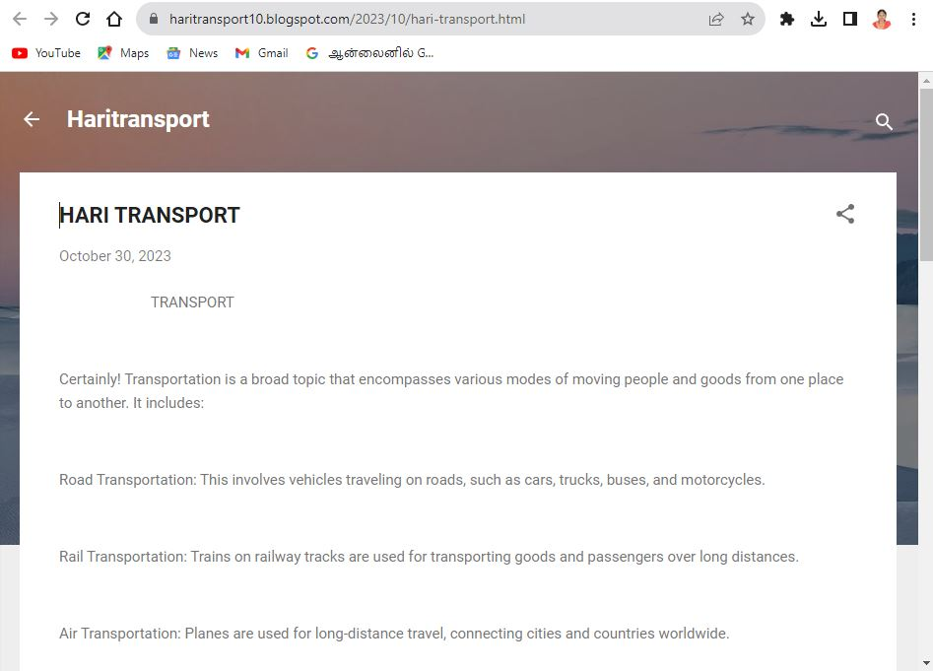

ASSIGNMENT 2:

Create a new Facebook business page and post one social media poster for your brand.

URL: <https://www.facebook.com/haritransport10?mibextid=ZbWKwL>

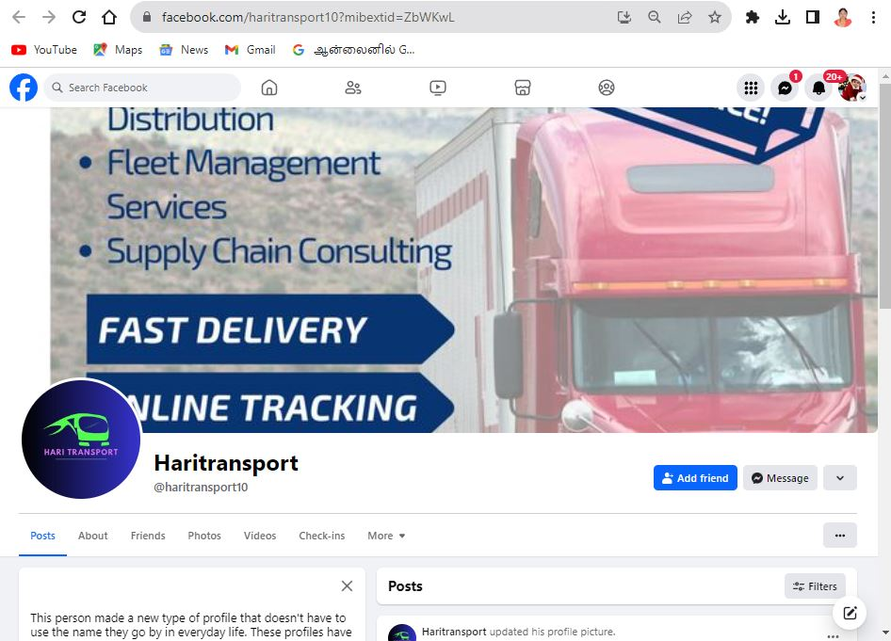

ASSIGNMENT 3:

Create and design a advertisement poster using Canva.

URL: <https://m.facebook.com/story.php?story_fbid=pfbid02MY57wVdRqKdj4LV3xQea8zCe64ERGPuwXZXH8e8ejpXNKcGwqfwYVedCDbqnuP7Ul&id=61552770834073&sfnsn=wiwspmo&mibextid=VhDh1V>

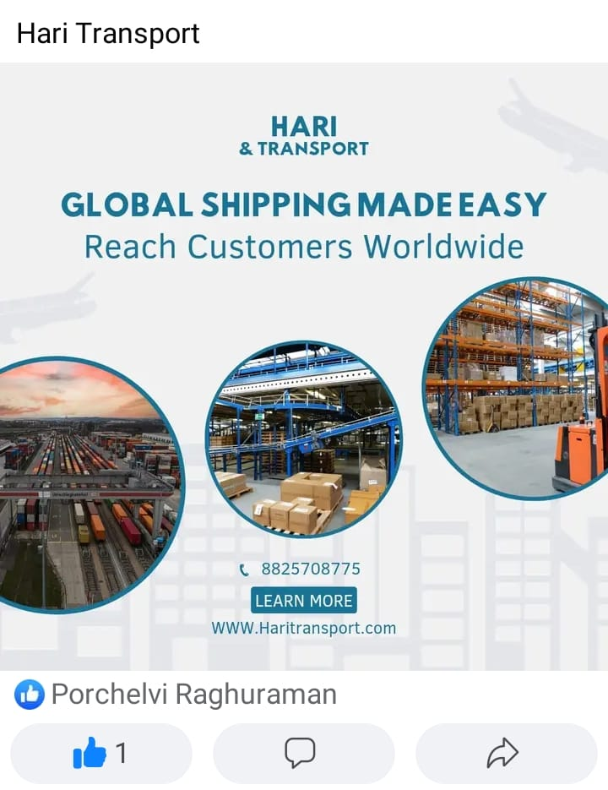

ASSIGNMENT 4:

Create an E mail newsletter design using Mailchimp or Canva tool.

URL: <https://haritransport10.blogspot.com/2023/10/hari-transport-email-newsletter.html>

